**Enterprise Resource Planning**

**Training User Manual**

**VERSION 12.0.0**

**Approval System**

# Administration

**Options**

1. [Purchase Order Approval](http://192.168.1.17:8080/zab/login?screen=poordheader&option=Purchase+Order+Approval&menuname=adminapp)
2. [Direct GRN Approval](http://192.168.1.17:8080/zab/login?screen=podrgrnheader&option=Direct+GRN++Approval&menuname=adminapp)
3. [Invoice Entry Approval](http://192.168.1.17:8080/zab/login?screen=opdoheader&option=Invoice+Entry++Approval&menuname=adminapp)
4. [Sales Return Approval](http://192.168.1.17:8080/zab/login?screen=opcrnheader&option=Sales+Return++Approval&menuname=adminapp)

# Purchase Order Approval

* 1. **PO Approval Header**

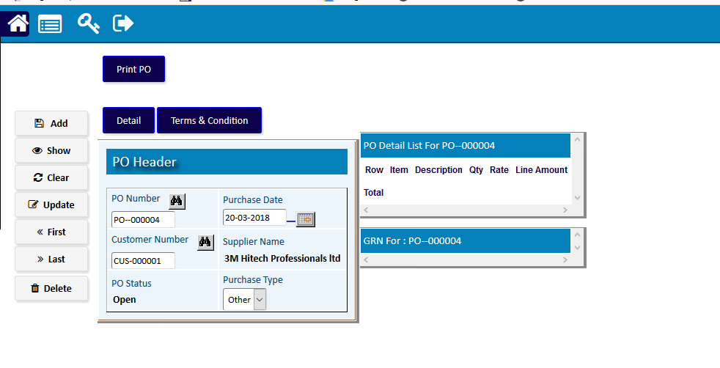

* 1. **PO Approval Detail**

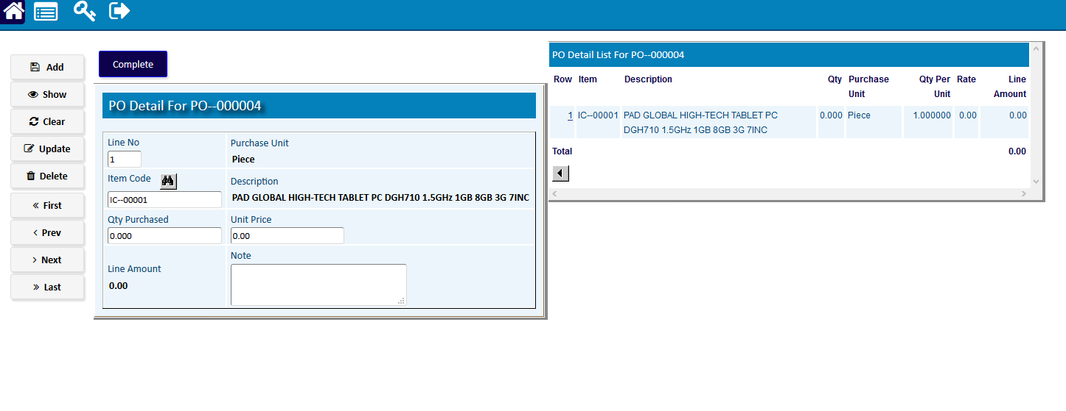

# Direct GRN Approval

* 1. **GRN Approval Header**

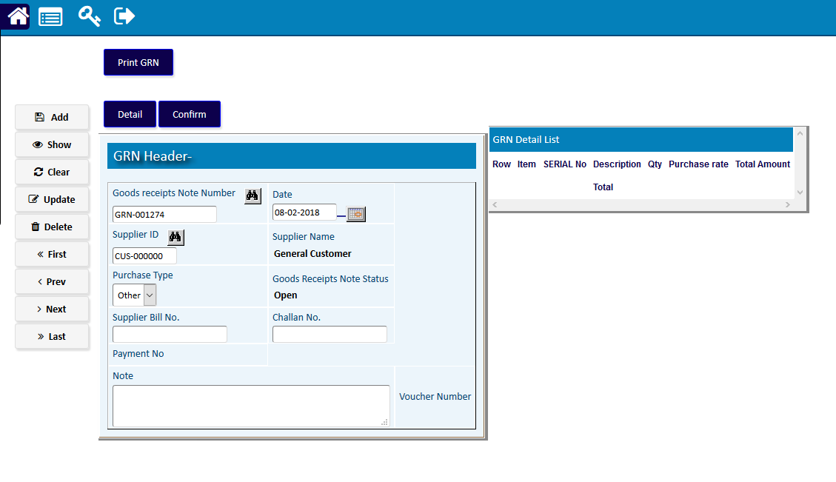

* 1. **GRN Approval Header**

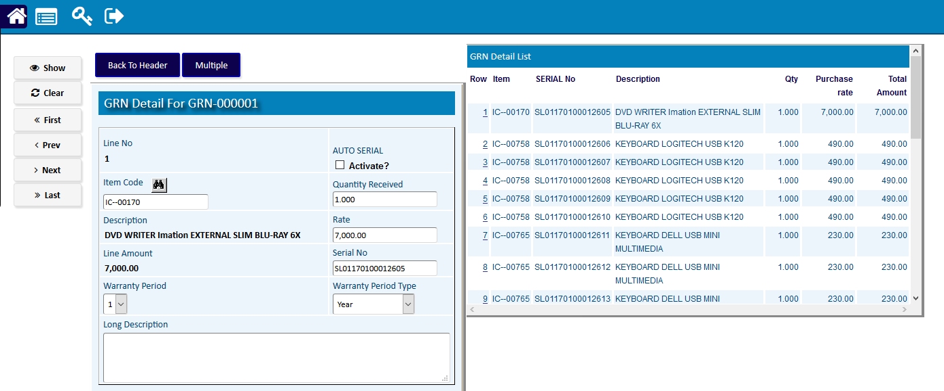

# Invoice Entry Approval

* 1. **Invoice Approval Header**

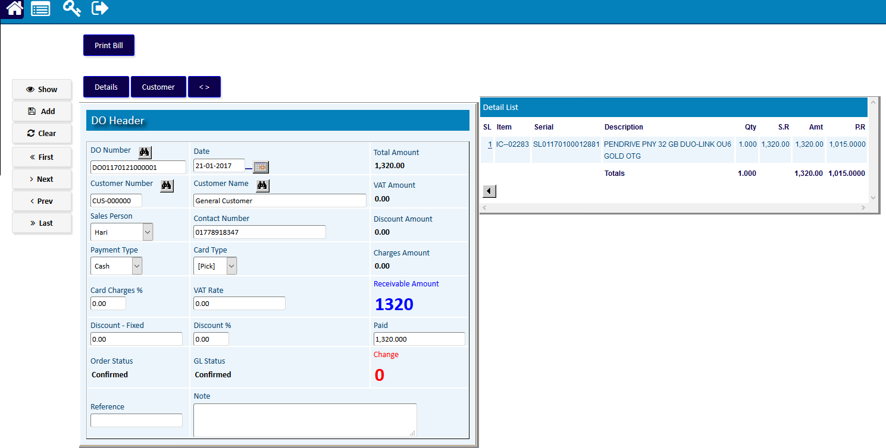

* 1. **Invoice Approval Header**

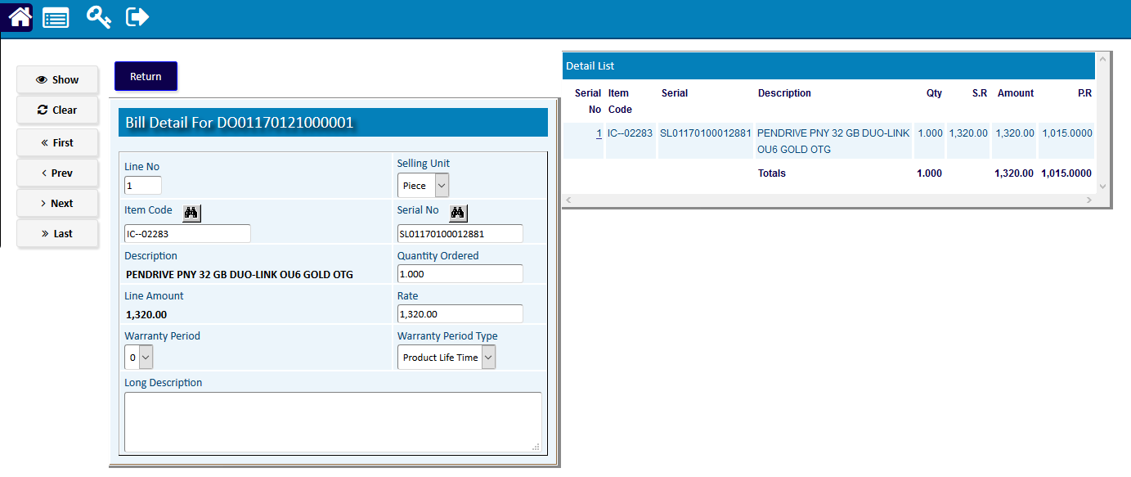

# Sales Return Approval

* 1. **SR Approval Header**

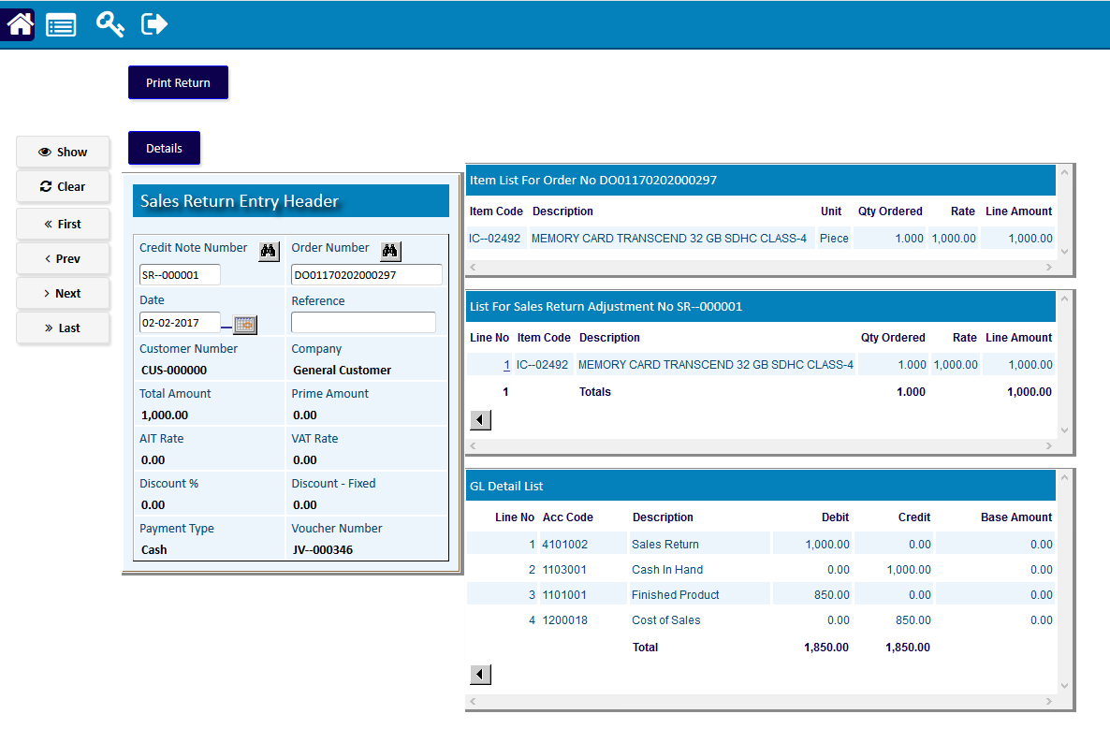

* 1. **SR Approval Header**

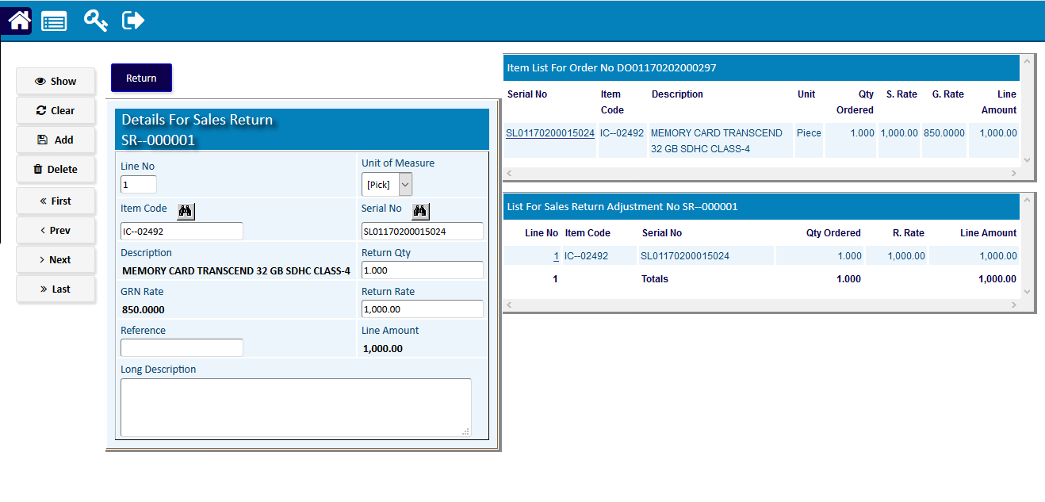

|  |  |  |
| --- | --- | --- |
| **Step 1** |  | Open System **>** Administration> Master Setup **>** Codes & Parameter (Open any screen to entry Code) |
| **Step 2** |  | Write Transaction code name & check the Activate box. Write number , Increment & Fill other fields if required. |
| **Step 3** |  | Click **Add** |
| **Result** |  | New Code entry |

